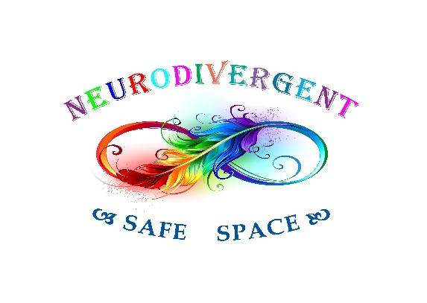
Service suitability form

We provide a service for a vulnerable group of individuals who are Neurodivergent (Autistic/PDA/ADHD/DCD/Tourettes Syndrome) and are experiencing mental health difficulties.
Due to the nature of their vulnerability, we need to ensure that our service is best placed to meet their needs and provide the most effective support available.
Please complete the questions below so that we can assess whether we are best placed to support your child/young person.

Name of child/young person: …………………………………………………………………………………………………
Date of birth of child/young person: ………………………………..
Name of person completing this form: …………………………………………………………………………………..
Relationship to child/young person: …..………………………………………………………………………………….
Your telephone number: ………………………………………………………………………………………………………..
Your email address: …..………………………………………………………………………………………………………….

- Is your child/young person Neurodivergent/Suspected Neurodivergent? Yes/No

- Is your child/young person experiencing mental health difficulties? Yes/No

- Does your child/young person have a diagnosed mental health condition? Yes/No

- If yes, please could you state their diagnosis/diagnoses below;

……………………………………….…………………………………………………………………………………………..

………………….………………………………………………………………………………………………………………..

…………………………………….……………………………………………………………………………………………..

……………………………………………………….…………………………………………………………………………..
- Does your child/young person have any other health conditions? Yes/No

- If yes, please could you state their other health conditions below;

………………….………………………………………………………………………………………………………………..

…………………………………….……………………………………………………………………………………………..

……………………………………………………….…………………………………………………………………………..

………………………………………………………………………….………………………………………………………..

- Does your child/young person require a carer or 1:1 support in group settings? Yes/No

- If yes, please provide information on what support is required in group settings;

……………………………………………………………………………………………………………………………………

……………………………………………………………………………………………………………………………………

……………………………………………………………………………………………………………………………………

……………………………………………………………………………………………………………………………………

……………………………………………………………………………………………………………………………………

……………………………………………………………………………………………………………………………………

Thank you for completing this questionnaire. We will contact you shortly to advise you if we are best placed to provide support and meet the needs of your child/young person.

All information provided will be kept confidential and will be stored securely as per GDPR requirements.
If you are completing this form online, please send it via email to: info@neurodivergentsafespace.co.uk

If you have any questions or concerns, please contact us via email at: info@neurodivergentsafespace.co.uk

