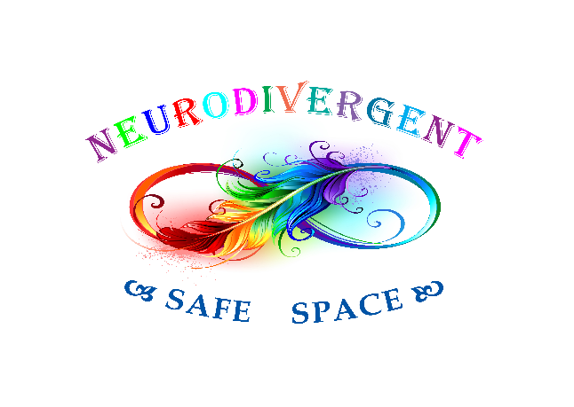

Volunteer Application Form
Contact Information
Name
Address
Postcode
Home Phone
Mobile Phone
E-Mail Address

Neurodiversity
Are you Neurodivergent? (Autistic/PDA/ADHD/DCD – diagnosed or undiagnosed)

_____ Yes, I am Neurodivergent ______ No, I am not Neurodivergent

Availability
During which hours are you available to volunteer?
Weekday mornings | Weekend mornings
Weekday afternoons | Weekend afternoons
Weekday evenings | Weekend evenings

Volunteer Work Interests
Tell us in which areas you are interested in volunteering
Administration
___ Running club sessions
Events
Community
Fundraising
Supporting members during the club
____Counselling
Phone bank
Newsletter production
Volunteer coordination

Why do you want to volunteer?
Please tell us why you want to volunteer with Neurodivergent Safe Space

Special Skills or Qualifications
If you have any special skills or qualifications that you have gained from previous paid or volunteer work, or through activities, clubs, hobbies, or sports, please list them here.

Previous Volunteer Experience
Have you had any previous experience volunteering? If so, please write it down here

Person to Notify in Case of Emergency

Name
Relationship to You
Address
Postcode
Home Phone
Mobile Phone
E-Mail Address

Agreement and Signature
By submitting this application, I confirm that what I have written is true and complete. I understand that if I am accepted as a volunteer, any false statements, omissions, or other misrepresentations made by me on this application may result in my immediate dismissal.

Name (printed)
Signature
Date

Our Policy
It is the policy of this organization to provide equal opportunities without regard to race, color, religion, national origin, gender, sexual preference, age, or disability.

Thank you for completing this application form and for your interest in volunteering with us.

Please email your completed form to: info@neurodivergentsafespace.co.uk
Once we have received and reviewed your form, we will be in contact with you to discuss the next steps.

All information provided on this form will be kept confidential and stored securely as per GDPR regulations.

If you would like to withdraw your information from our records, please contact us at: info@neurodivergentsafespace.co.uk and we will destroy all records.

